**Ec2 & EBS**

**Assessment**



Name – Maithely Sharma

College – University of Petroleum and Energy Studies

EmployeeID – 4057

1. Create an EC2 instance (Ubunutu 18.04, T3 nano).(instance A)

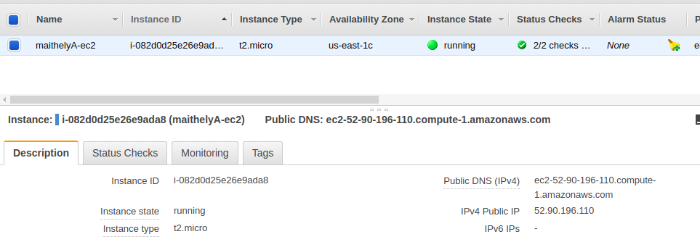

2. Create AMI of above instance and launch it. (instance B)

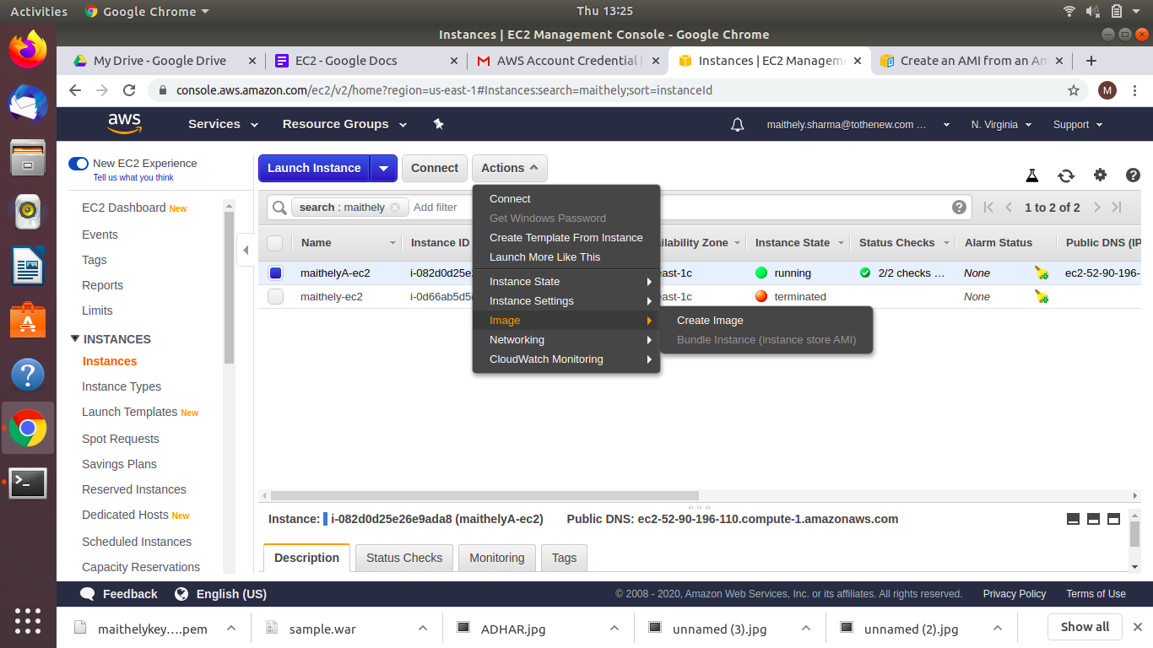

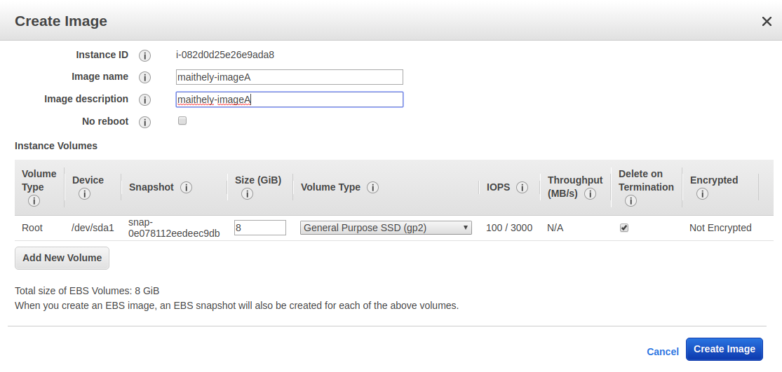

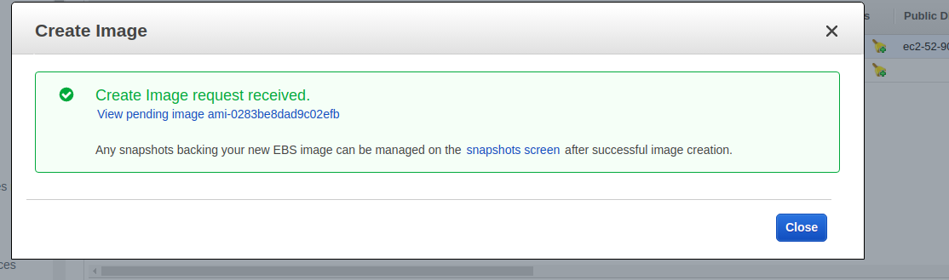

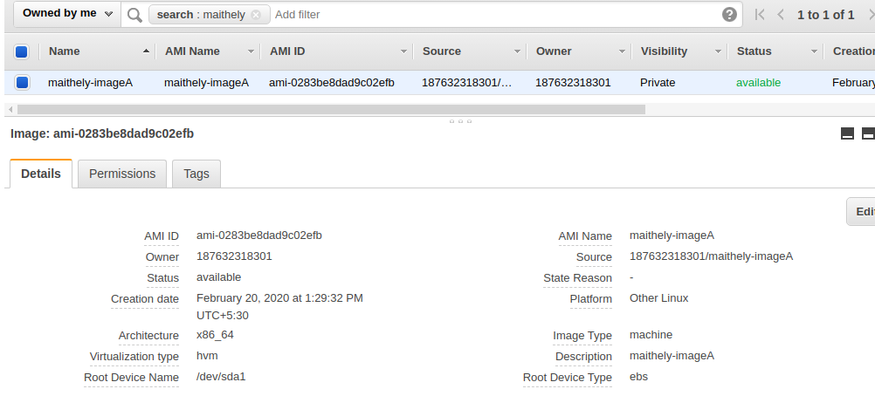

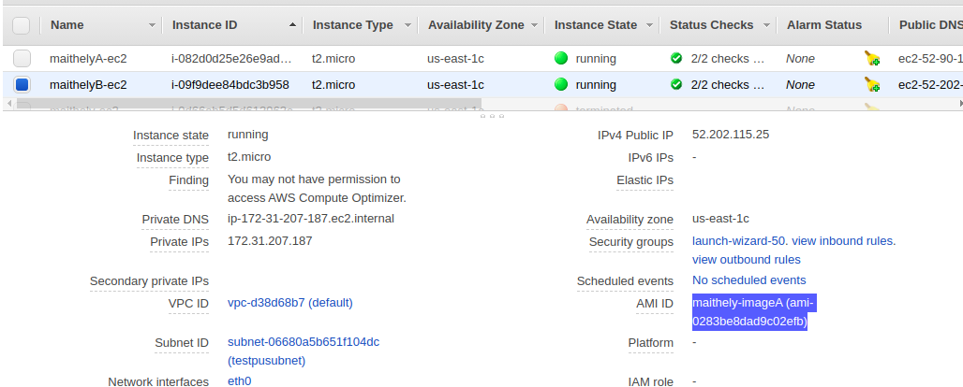

3. Attach EBS (8 GB) on that running instance.

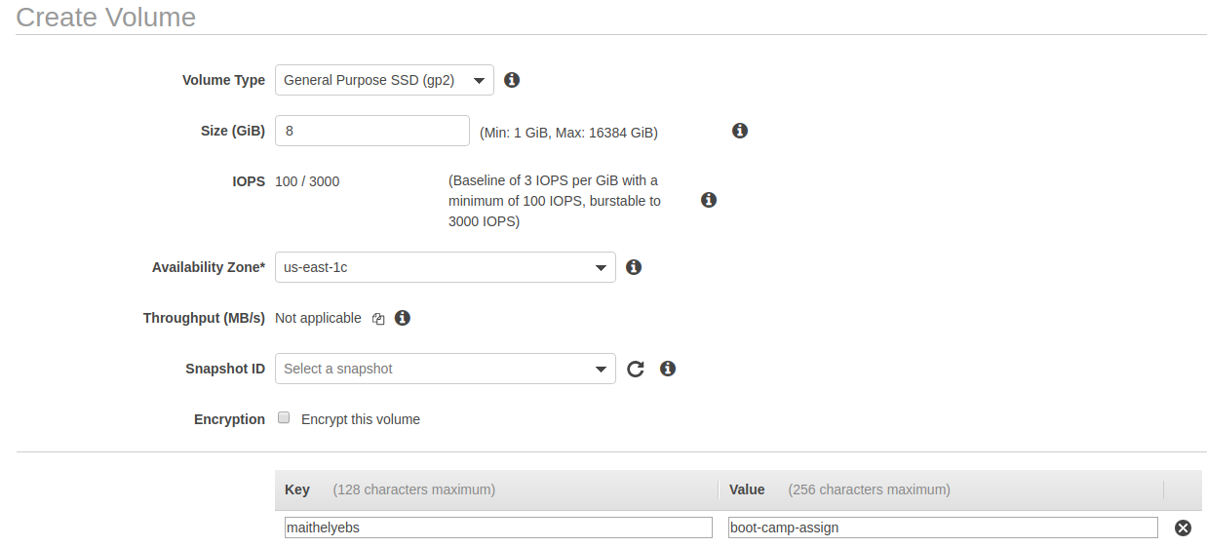

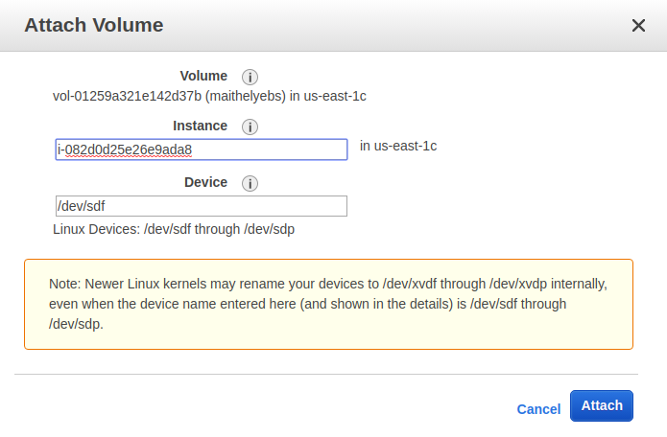

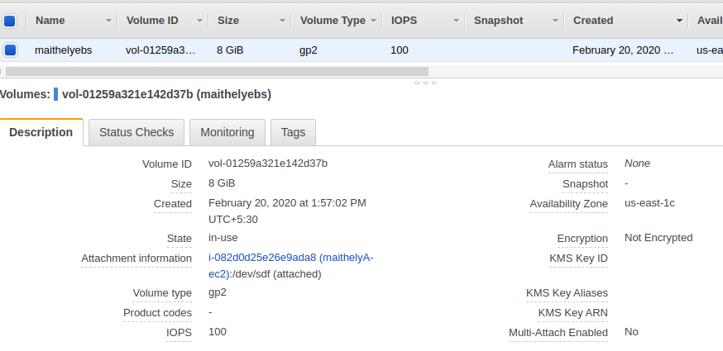

4. Stop, Start, Restart that EBS ( EBS must be auto-attached).

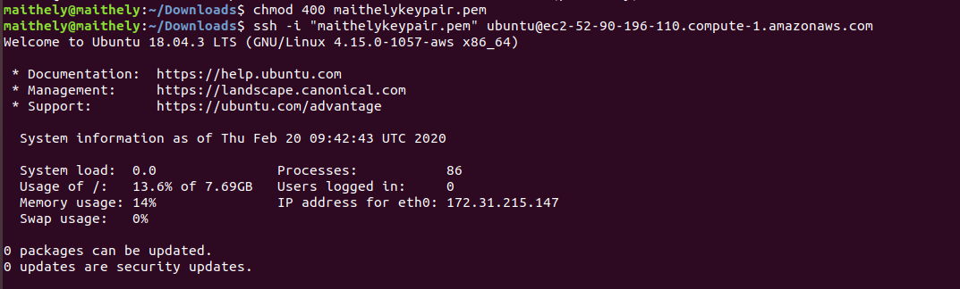

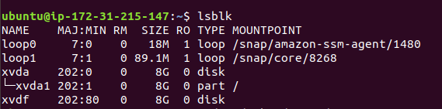

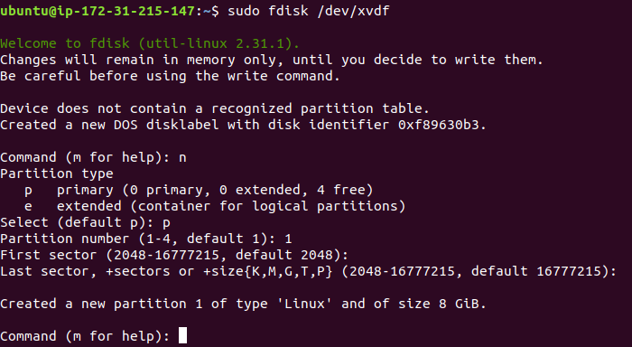

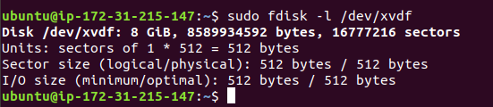

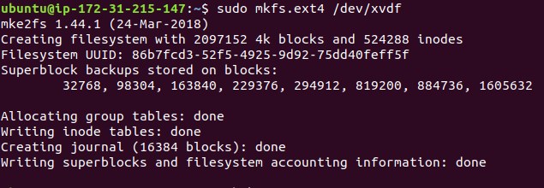

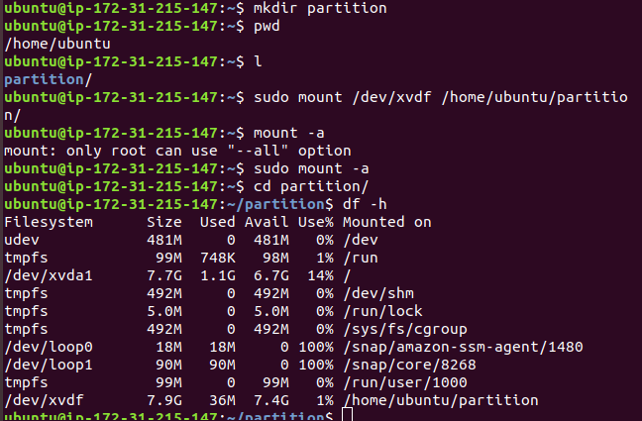

Sudo vim /etc/fstab

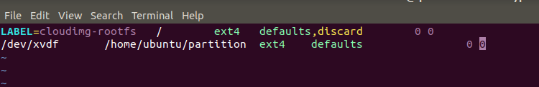

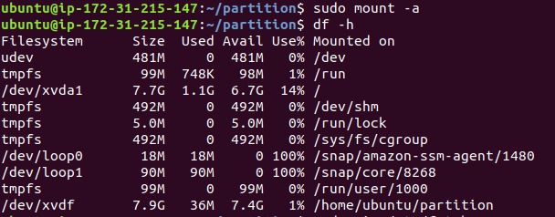

STOP INSTANCE:

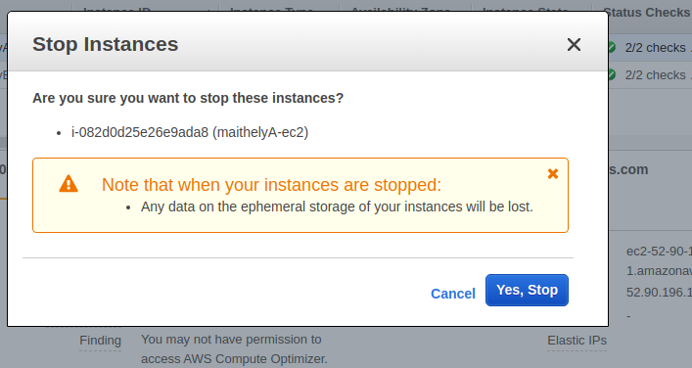

START INSTANCE:

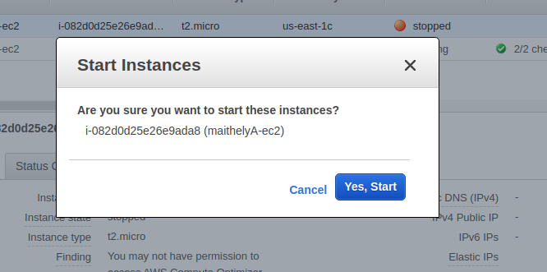

Ssh again:

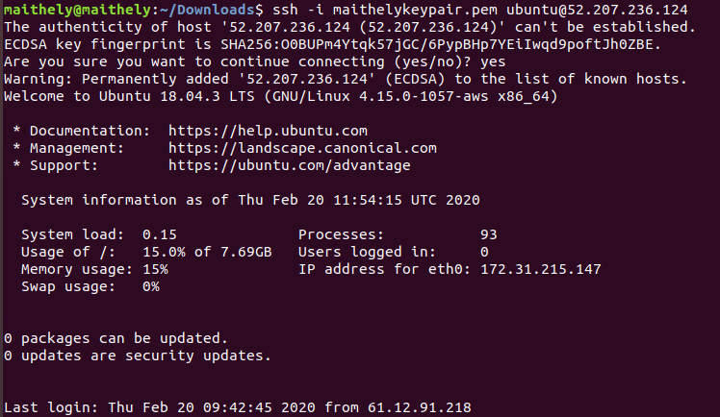

Now check the mounted partition again:

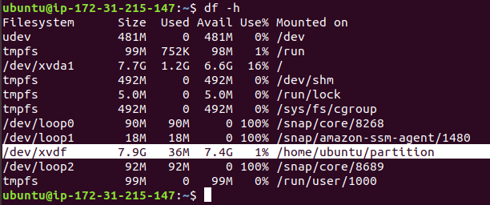

5. Make some mistake in fstab file, stop and start the instance, then troubleshoot it.

Make a mistake

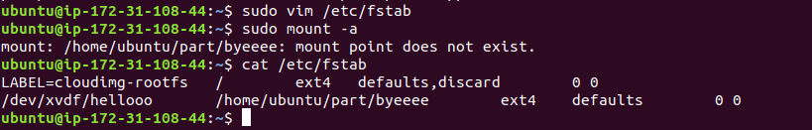

Stop instance :

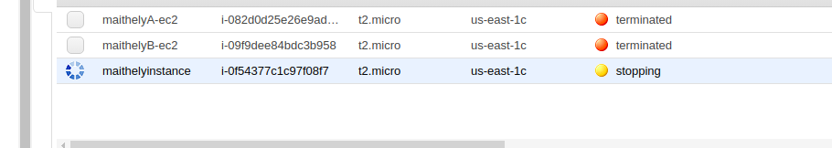

Start instance :

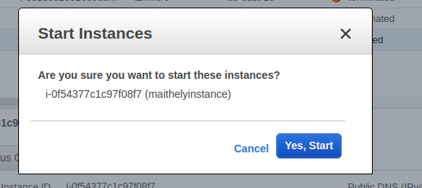

Login



Now you can see that connection has been refused.

Now we have to correct the FSTAB file:

1. Stop the instance

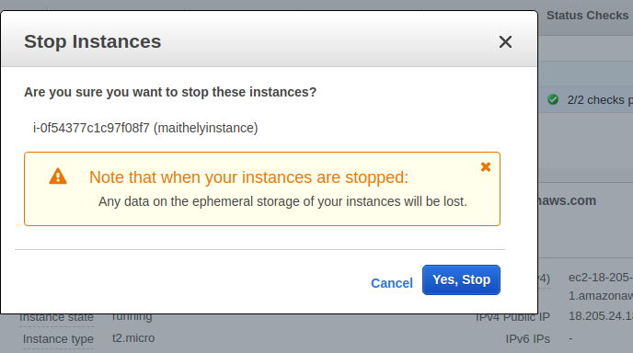

1. Detach the root EBS volume from the *instance*

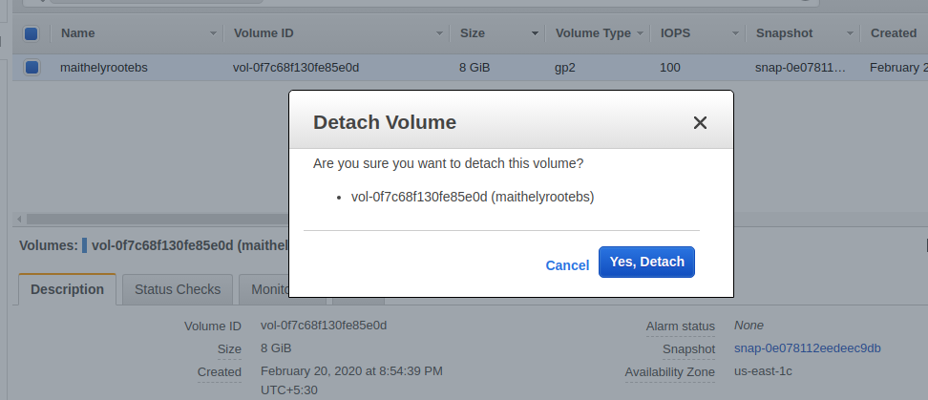

1. Select the *instance* EC2 instance in the AWS console and view the content in the “Description” tab in the window bellow the instance list and Search for the “Root device” field

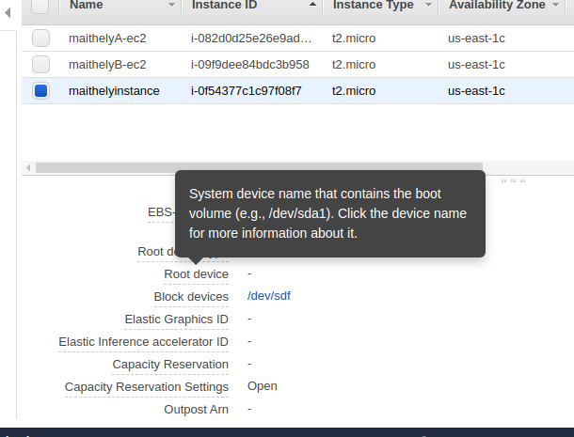

1. Click on the link next to it i.e:EBSID and take note of it for the following steps (maithelyvol1)

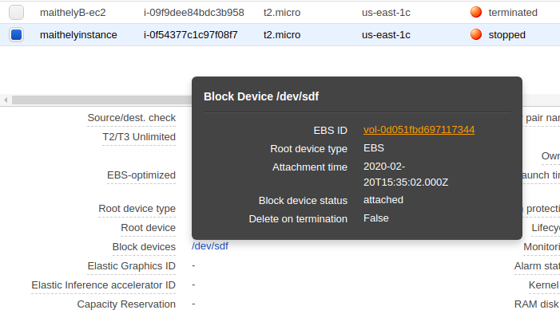

|  |  |
| --- | --- |
| vol-0d051fbd697117344 |  |

1. Now detach the above mentioned volume.

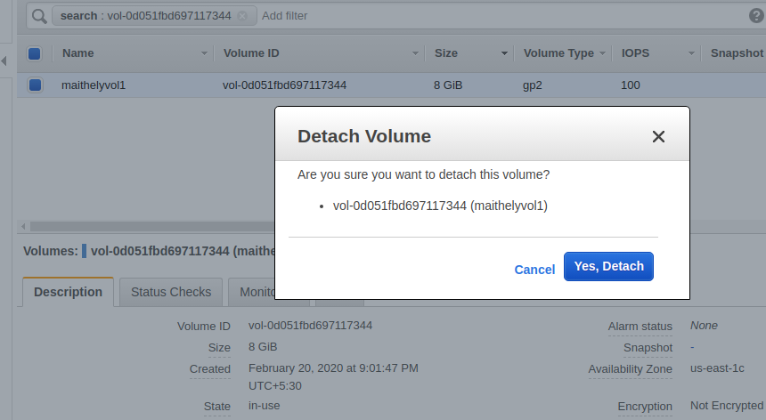

1. Create a brand new micro instance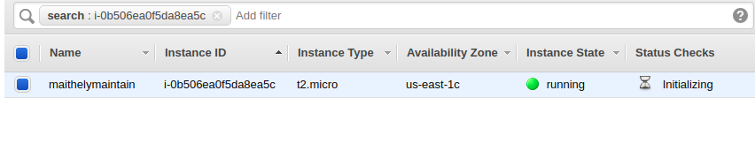
2. Attach root volume to new instance created

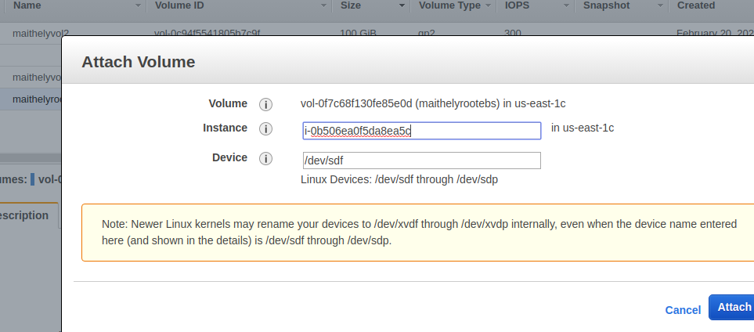

1. Ssh onto new instance created

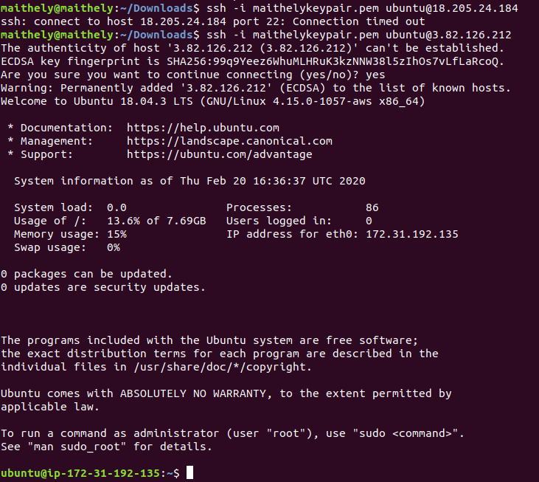

1. Check the disk to ensure that the old root EBS volume is available and get the device name

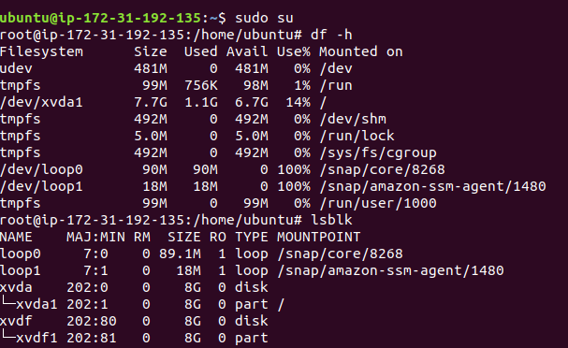

1. Create the directory that you want to mount the volume to

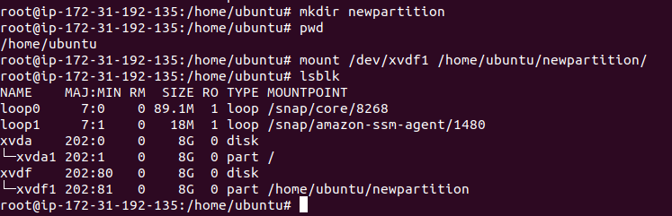

1. Now make changes in the fstab file to make it correct
2. Unmount the drive from the machine



1. Switch back to the AWS Web Console and detach the volume from new instance created

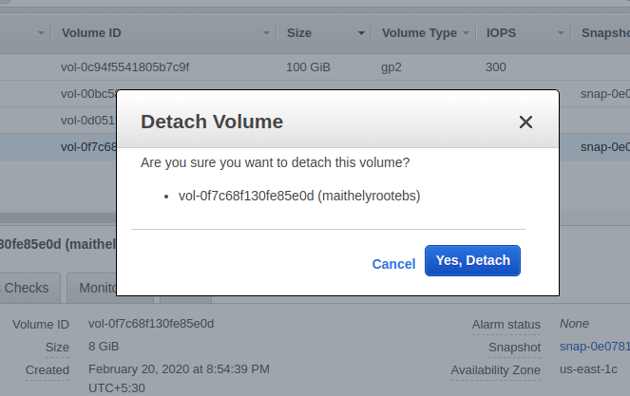

1. Now reattach the volume to the older instance as root volume

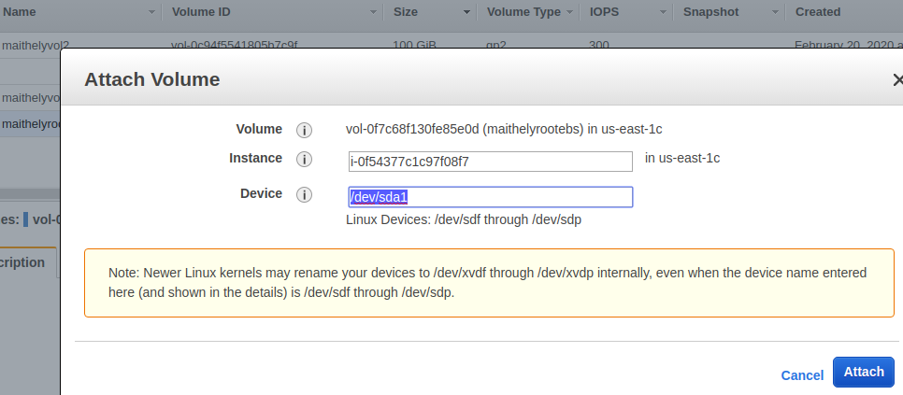

1. Now start the older instance

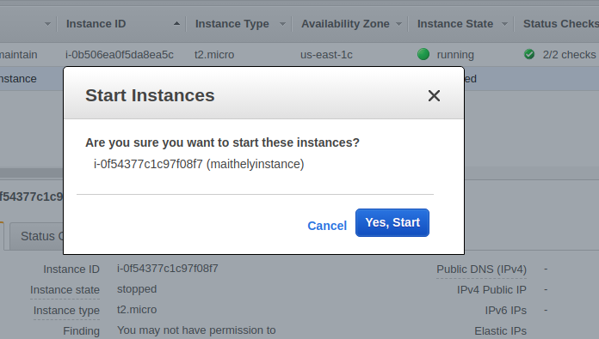

1. Now ssh with the instance started

6. Resize the EBS from 8 to 10GB

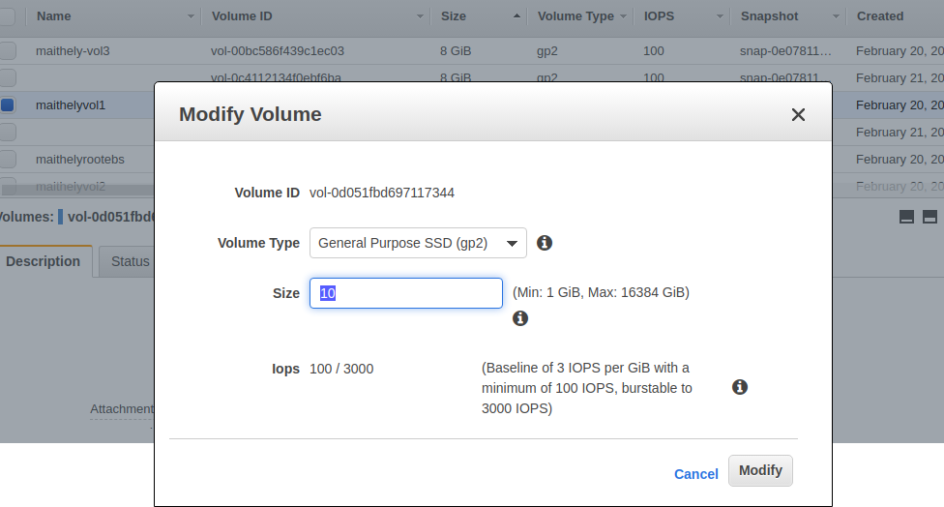

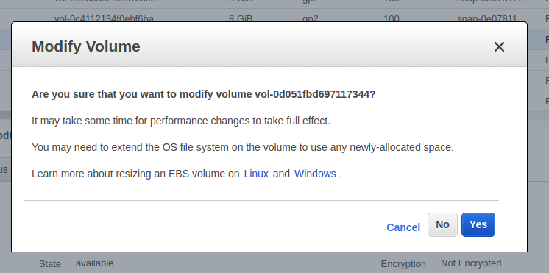

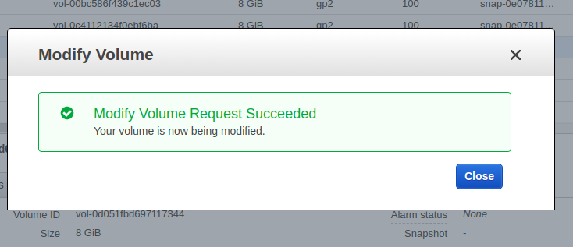

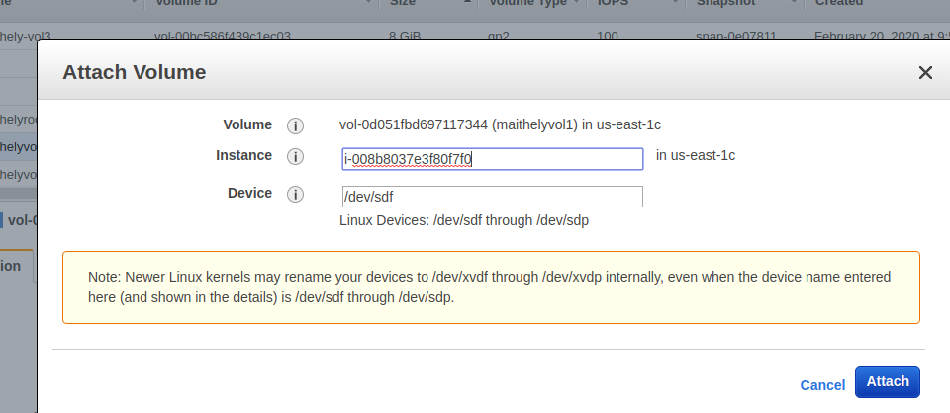

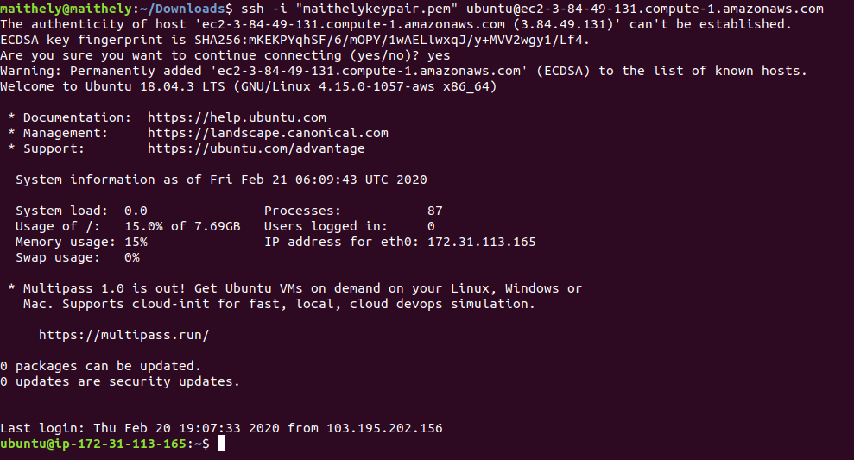

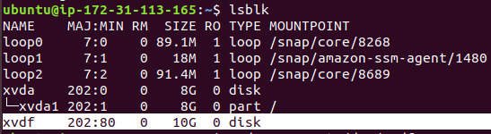

When there is root volume and we have made a partition.

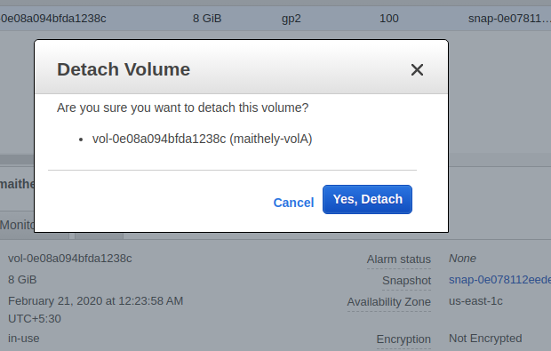

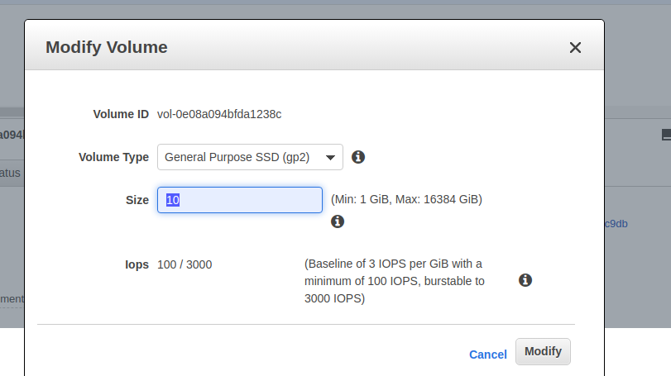

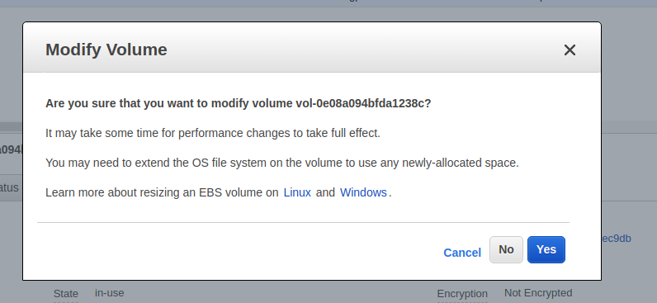

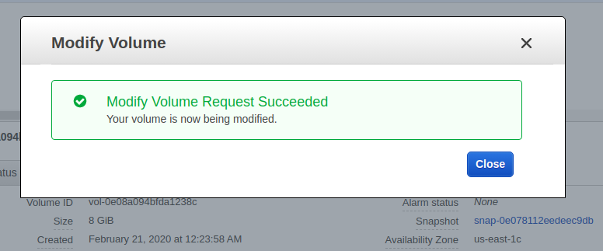

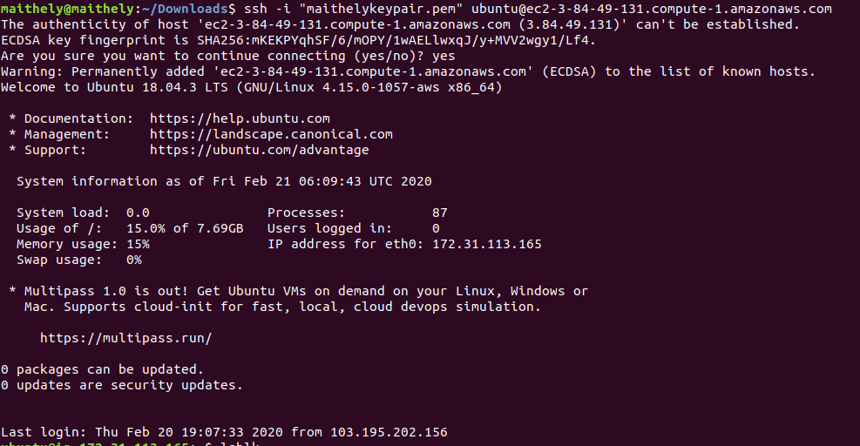

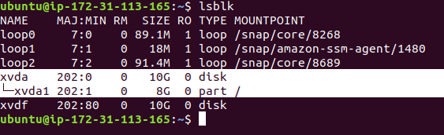

Now we are extending the partition

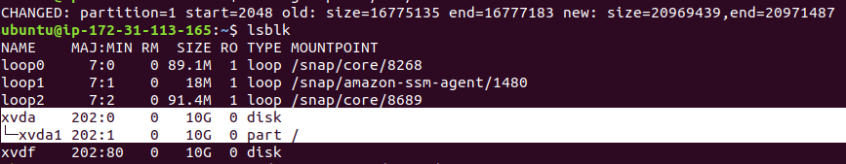

7. SSH from one instance A to instance B.

Create instance 1

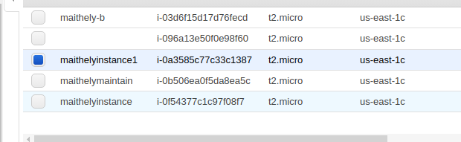

Now scp and ssh at instance1

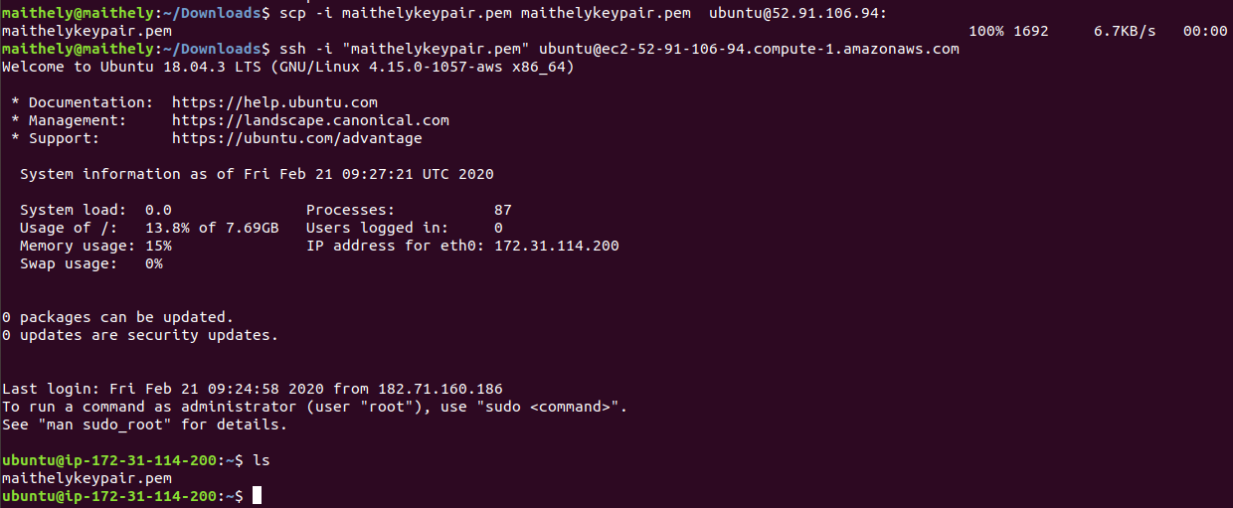

Now ssh from instance 1 to ip:2 and see that IP has changed

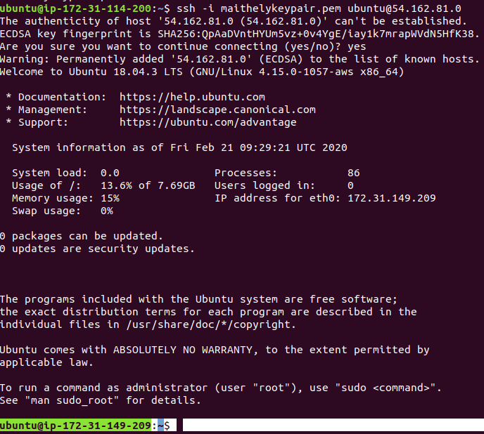

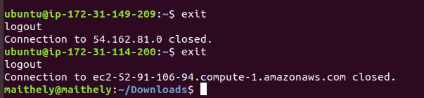

8. Copy the EBS in different region( oregon).

9. Detach the root EBS, create its snapshot, than create the AMI and run it as instance such that nginx should be preinstalled at the boot time of instance.

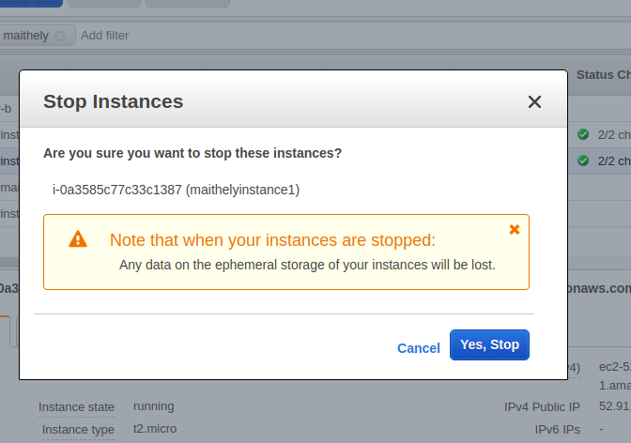

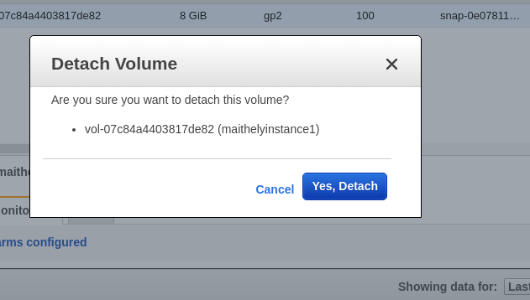

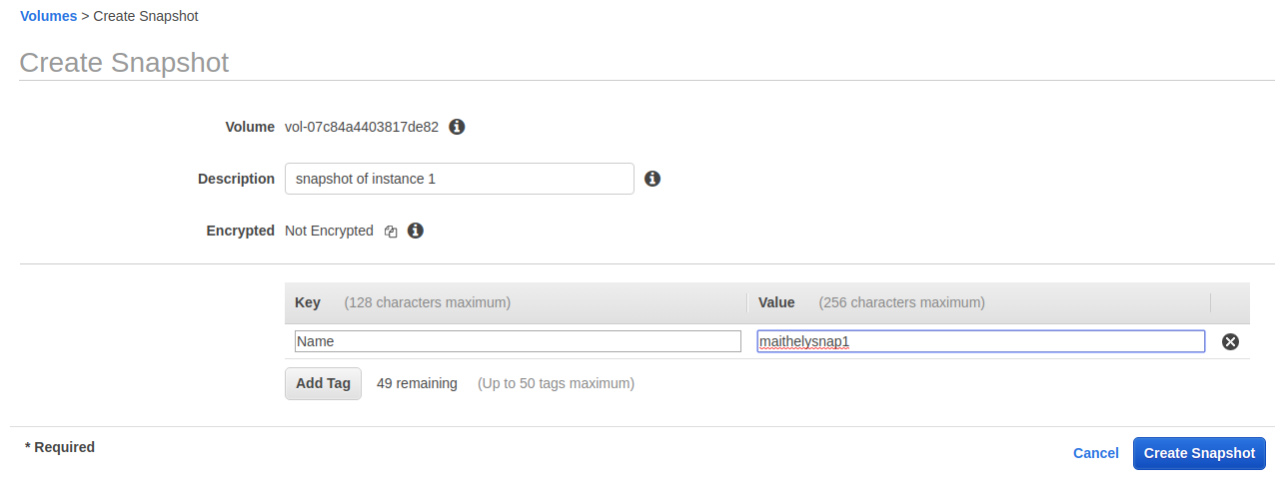

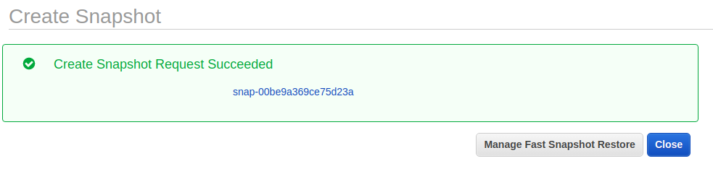

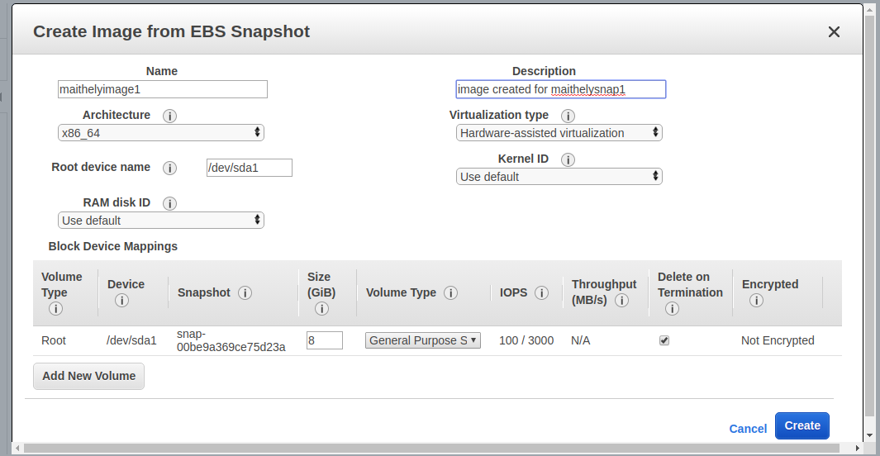

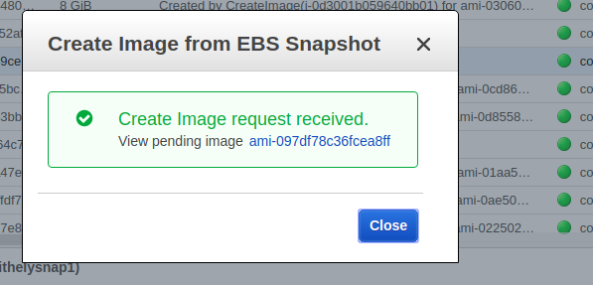

Create an instance from image created

